Profitbase AS

Profitbase Planner
Configuration and Operation
CapEx module
Profitbase

09.09.2025

Version 3.6



Content

Content 2
1 Abstract, intended audience and pre-requisites 3
2 Common functionality 3
3 Principle of operation 5
Plan by individual year 5
Flexible organizational input level 5
Flexible input sheet 7
Input columns 7
Dimensionality 7
Investment status 7
4 Module configuration 8
Publish and name module, control row context right-click menu options 8
Setup of the CapEx module 8
Column setup 9
Dimension setup 10
Investment status 10
Translations 10
5 Settings 12
Investment Depreciation 12
Investment Accounts 12
Declining Balance StopValue 13

Date: | Version: | Changed by: | Changes:
29.5.2020 | 0.0 | TN | Initial content
12.10.2020 | 1.0 | TN | Revised
20.05.2021 | 2.0 | TN | Revised for Planner v5
07.07.2022 | 3.0 | TN | Revised for Planner v5.2
06.12.2022 | 3.1 | TN | Revised for Planner V5.2.4
24.02.2023 | 3.2 | TN | Revised for Planner V5.4.0
24.06.2023 | 3.4 | TN | Revised for Planner V5.4.1
26.05.2025 | 3.5 | TN | Revised for Planner 6.1.0
09.09.2025 | 3.6 | TN | Revised for Planner 6.1.1

Abstract, intended audience and pre-requisites

The Profitbase Planner Configuration and Operation series consist of several documents dealing with the configuration and operation of individual Planner modules and functions.

The intended audience of this document is implementation partners configuring the solution initially and solution administrators responsible for operating it thereafter.

This document assumes that a Profitbase Planner solution has been deployed and that access to this solution is given to the reader.

The CapEx module is included as a standard Profitbase Planner module.

Common functionality

Changes made to input sheets are not saved automatically. To save changes, click the “Save” button. The “Save” button will remain disabled until a change has been made.

To undo all unsaved changes, click the “Refresh” button.

To undo the last of a series of unsaved changes, click the Ctrl and Z keys simultaneously.

To insert new rows to an input sheet, right-click in the sheet and select one of the available options:

- Insert row
- Insert row below
- Insert copy of row

To delete a row from an input sheet, right-click the row in question and select:

- Delete row

Inserting and deleting rows can be controlled as part of the configuration, see Publish and name module, control row context right-click menu options.

Please note, that although the row is no longer visible in the input sheet, the change must be committed using the “Save” button or undone using the “Refresh” button.

In input sheets, editable fields are distinguished from non-editable fields by fill color, editable fields have by default a white fill color.

In setting tables, a so-called ranked input concept is often used for the dimensional context. Ranked input allows for a high-level selection of dimensional nodes and gives the opportunity to alter the rank or specificity between rows.

A ranked input cell can be set through the ranked input selector by clicking the cell value (cell will display 3 dots if no value is set):

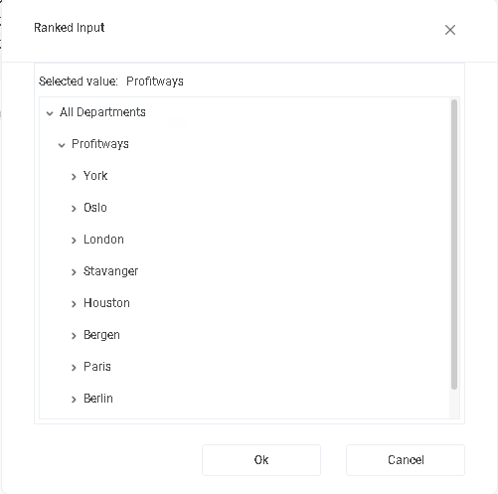

The ranked input selector will display the dimensional hierarchy and allows for the selection of a high-level dimensional node. The selection of a high-level node implies that the setting applies to all sub-ordinate nodes.

Select node and click “OK”.

Click “Cancel” to leave the selector without selecting.

In a table containing multiple rows, the rank or specificity of individual rows can be altered by moving the row up (decrease specificity) or down (increase specificity) by right-click the row in question and selecting:

- Move up
- Move down

The less specific the setting is, row should be high up in the table. The more specific the setting is, the further down in the table the row should reside.

Principle of operation

The CapEx module provides an input sheet for contributors to plan investments and based on it, it will generate depreciation cost and maintain the balance accounts associated with the investments.

Plan by individual year
Investments are input by individual year by selecting the year in question from the filter dropdown list of years:

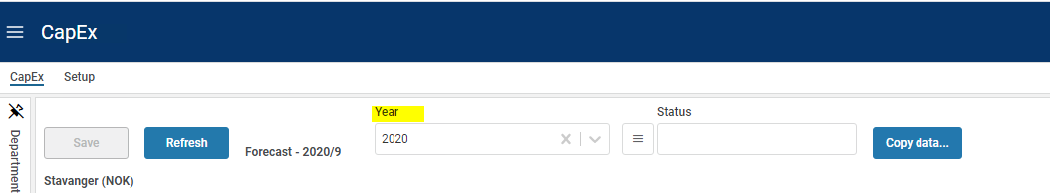

For new years, it may be relevant to copy data from a previous year. This can be done by accessing the “Copy data…” button. This will reveal a popup in which year can be selected:

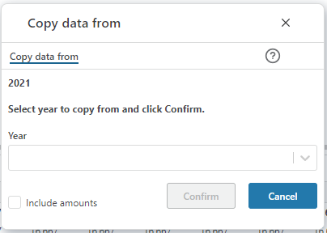

Older data can be deleted in the “Setup” page by clicking the “Delete data…” button to reveal the following dialogue:
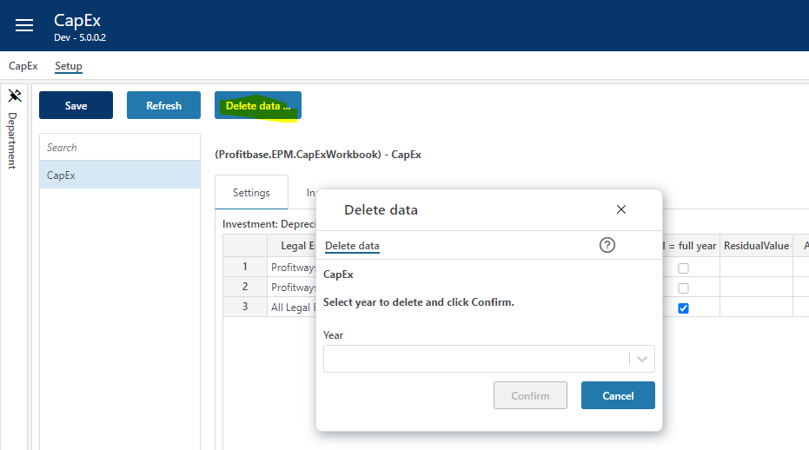

Flexible organizational input level

Investments can be input from anywhere in the organizational dimension. Each investment must, however, be attached to a department.

If a department is selected when input is done, this department is automatically assumed to be the department for the investment.

If at a higher level, the legal entity and department columns are automatically visible and relevant values must be selected from the dropdown lists attached to the columns:

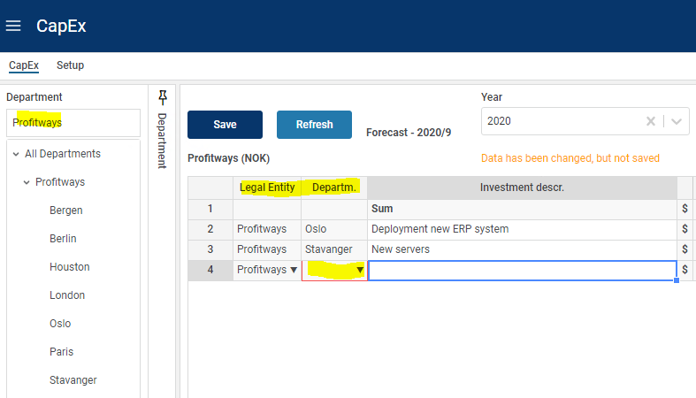

Click the icon to view the transactions generated from the row in question.

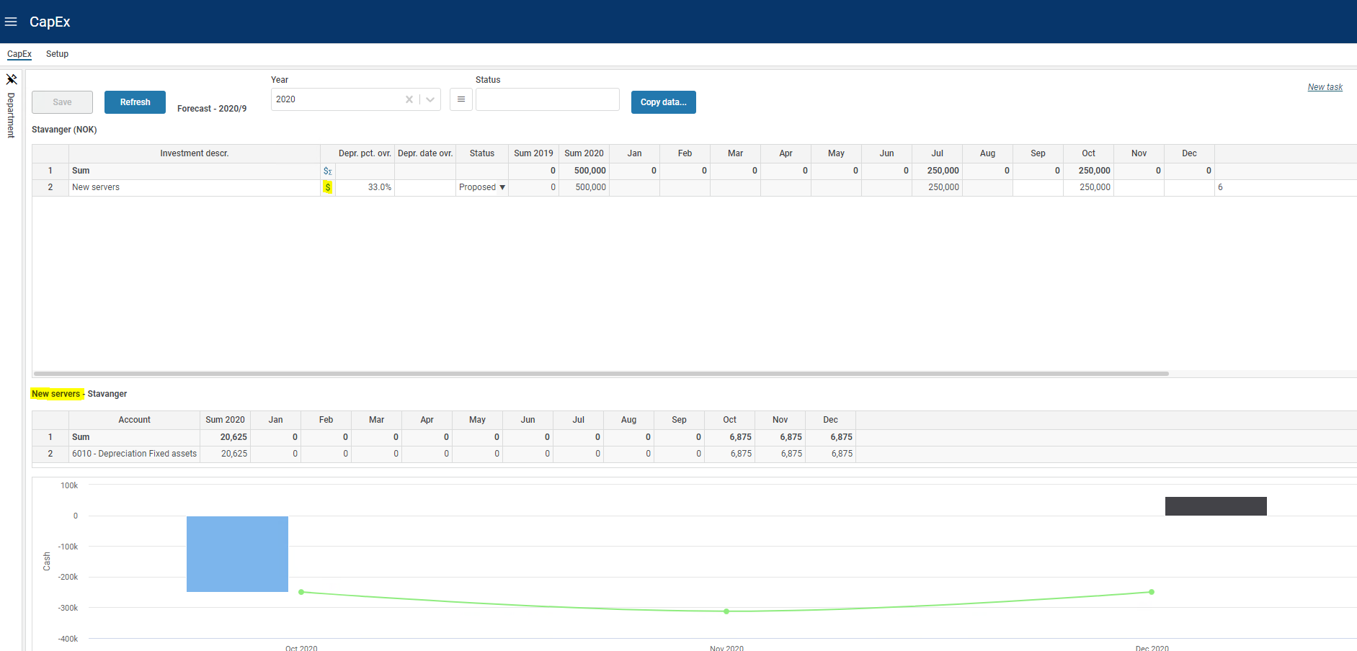

Flexible input sheet

Input columns
Depending on the familiarity of contributors with investments, asset accounts, depreciation rates and so on, the input sheet may be configured differently.

By default, the depreciation rate and the start date for depreciation are input fields:

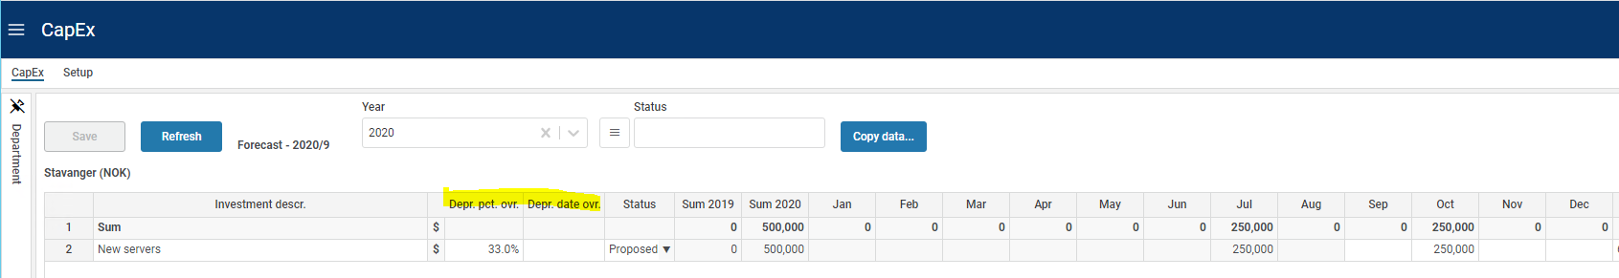

This can be changed so that the contributor selects from asset groups for which depreciation rates and accounts are automatically associated.

For details on defining input columns, please refer to Column setup for details.

For details on detailing settings per asset group, please refer to Settings for details.

Dimensionality
The basic dimensionality of the CapEx module is department and individual.

Extra dimensionality may be added as needed, please refer to Dimension setup for details.

Change dimensionality of an input row

The current dimensionality of an existing input row may be changed (subject to the configuration, see Publish and name module, control row context right-click menu options by right-clicking the row in one of the dimensional columns and selecting “Change dimensionality”. This will reveal a pop-up in which a new dimensionality can be set:

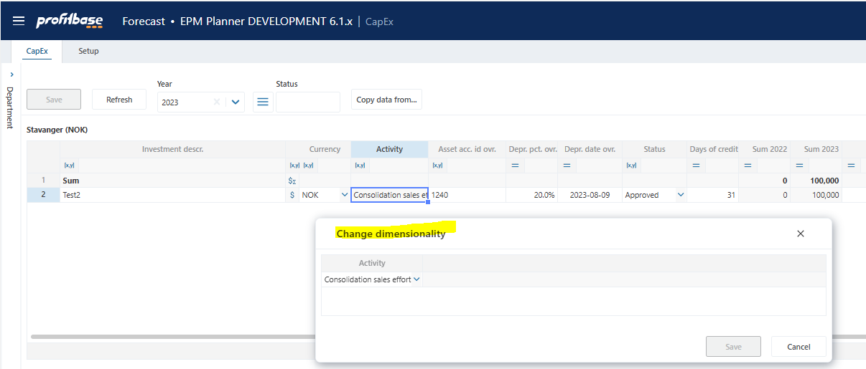

Investment status
An investment status table can be defined with behaviors such as include in plan which determines whether investments of a certain status is to be included in the plan or not.

Please refer to Investment status for details.

Module configuration

Publish and name module, control row context right-click menu options
Select the “Input Settings and Administration” workbook and go to the “Setup” page, and edit the “Input modules” table:

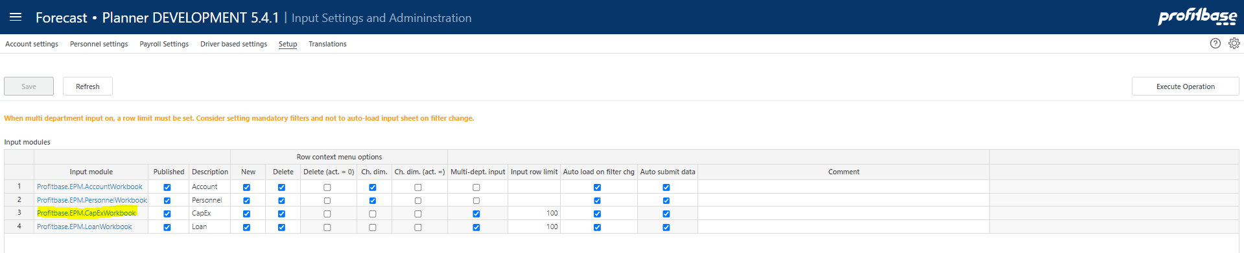

Column | Description
Input module | The name of the input module. The Input module column is an action link that will open the module in admin mode that means that changes are possible regardless of the “Published” column setting.
Published | Indicates that the input module is Published or not (checked | unchecked). If not published (unchecked), changes will not be possible unless opening the input module using the action link in the “Input module” column.
Description | The module’s default name. Translations can be added in the Translations tab.
Row context menu options (right-click)
New | Insert new row and Insert copy of row is allowed (true) or not allowed (false). Default is true.
Delete | Delete row is allowed (true) or not allowed (false). Default is true.
Delete (act. = 0) | Delete row is allowed only if row contains no actuals (true). Available for selection only if “Delete” is true.
Ch. dim. | Change dimensionality is allowed (true) or not allowed (false). Default is true.
Ch. dim. (act. = 0) | Change dimensionality is allowed only if row contains no actuals (true). Available for selection only if “Ch. dim.” is true.
Multi-dept. input | Always true for this module.
Input row limit | Max. row limit returned that allows input. If row limit is reached, data is limited, and a warning is given to say that data set must be narrowed down to allow input. When multi-department input is set to true, a row limit must be set.
Auto load on filter chg. | By default, data is loaded automatically on filter change (true). When multi-department input is used, it may be desirable to first set all filters and then load the data. If this is the case, set this option to false. End user will have to use the Refresh button to load data.
Auto submit data | Always true for this module.

Setup of the CapEx module

The CapEx module is configured in the “Setup” page of the “CapEx” workbook. In the “Setup” page, select the “Input model” tab:

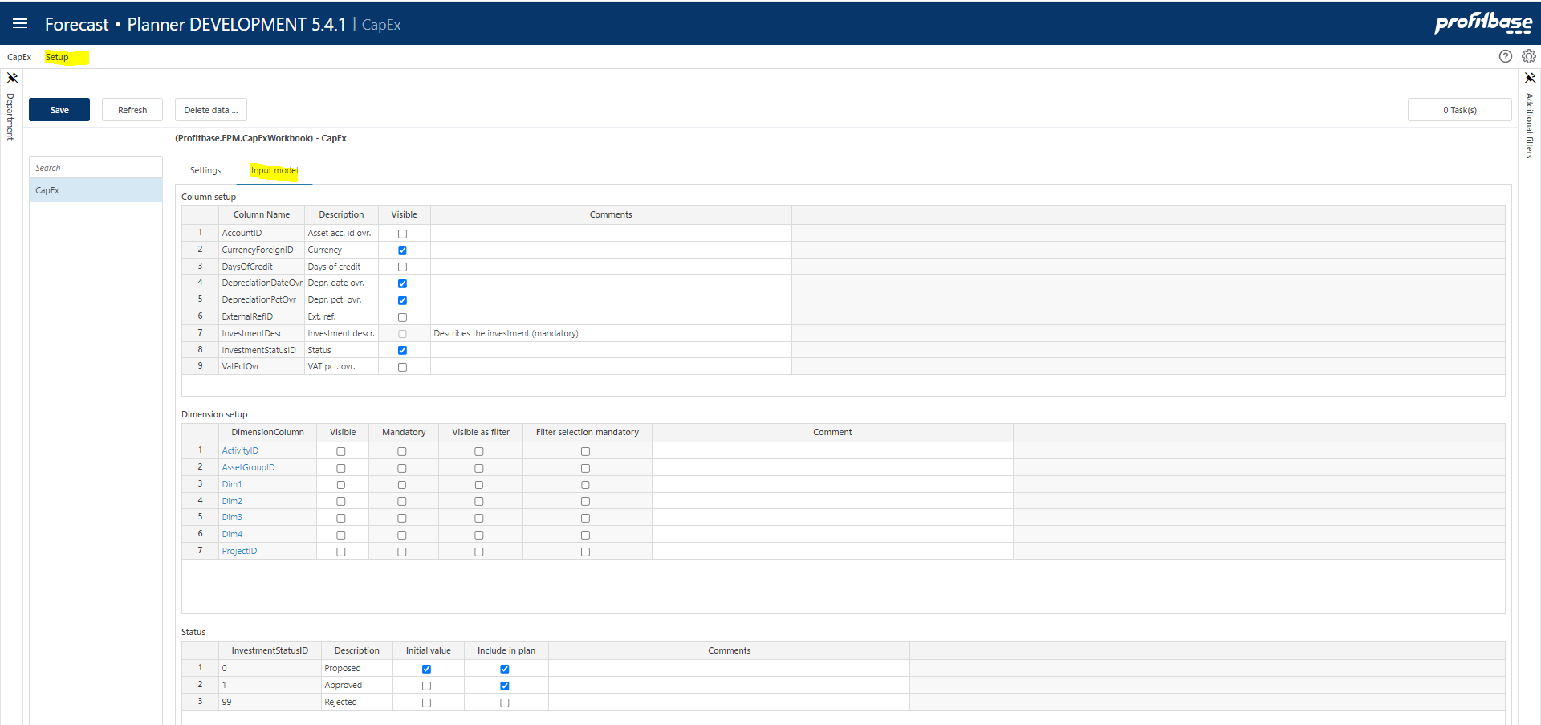

The module can be published by checking the “Published” checkbox and clicking the “Save” button. Conversely, the module can be taken offline by unchecking the “Published” checkbox.

Column setup

The module contains several input columns that may or may not be used depending on what kind of loan functionality is relevant by selecting and/or deselecting input columns.

The following columns are always present and thus not available for selection:

Text: The investment name or description. Mandatory.
Amounts (per month): The investment (acquisition) amount for the month in question. Mandatory.

The columns available for selection are selected in the “Column setup” table:

Column | Description
Column Name | The internal column id. Preset.
Description | The column’s default heading. Translations can be added in the Translations tab.
Visible worksheet | Indicates whether the column is visible in the input sheet (checked) or not (unchecked)

AccountID: the asset account override, column is default not visible. The default asset account is set in the “Investment Accounts” setting table and will in most cases suffice. Please refer to Investment Accounts for details.
DaysOfCredit: the number of days of credit for the investment, column is default not visible.
DepreciationDateOvr: the date for start of depreciation, column is default visible. The default value is the time of acquisition.
DepreciationPctOvr: the depreciation rate override, the column is default visible. The default value is set in the “Investment Depreciation” setting table. Please refer to Investment Depreciation for details.
ExternalRefID: use when appropriate, could be used for attaching an assetid or similar, the column is by default not visible.
InvestmentStatusID: Investment status dropdown, the column is by default visible. For details on defining Investment statuses, please refer to Investment status.
VatPctOvr: the VAT rate override, the column is by default not visible.

Dimension setup
There is a pre-set number of dimensions to select and name.

Note the “Asset group” dimension. This dimension is part of the dimensionality available for defining CapEx settings. If CapEx settings are refined down to asset groups, the “Asset group” dimension should also be selected (i.e. be visible) in the input sheet.

Column | Description
DimensionColumn | The dimension column id. This column is preset with the available dimensions ProjectID, ActivityID, AssetGroupID, Dim1, Dim2, Dim3 and Dim4.
Visible | Indicates that the column is visible and editable in the input worksheet or not (checked | unchecked)
Mandatory | Indicates that this dimension is mandatory, when adding a new investment, i.e. it is required to select a valid dimension member from the associated dropdown list.
Visible as filter | Some of the dimensions are available for selection as input filters (slicers). Indicates whether dimension is also an input filter (checked) or not (unchecked).
Filter selection mandatory | Indicates whether it is mandatory to set a value for the filter (checked) or not (unchecked)
Default filter value | Allows for a default value for the filter to be set. This can be a leaf level value or an aggregate level value. Editable only if dimension is visible and is used as a filter. Note that this is a default filter value, implying that if the model is started from the plan overview with a specific filter value set, the default will not apply.
Group source data | Not relevant for this module

Note on CPLegalEntityID (counterparty): this dimension is available in all modules, but it is only the Sales (IC) and Loans (IC) financial engines that creates counter transactions. Providing counterparty information to transactions that are not handled by the mentioned financial engines will NOT have it’s counter transactions automatically posted. Hence, when enabling this dimension, make sure that is understood by the client. Accounts piped through the Sales (IC) engine are set up in the Finance Settings workbook and the Account to engine mapping configuration.

Investment status

Investment statuses can be used to filter out certain investment. A filter is tied to the status in the “CapEx” tab.

For statuses to be selectable by the contributor, the “InvestmentStatusID” column must be visible, see Column setup for details.

Column | Description
InvestmentStatusID | The investment status id. Input field.
Description | The column’s default heading. Translations can be added in the Translations tab.
Initial value | Indicates that this investment status is the default status given to an investment when added to the input sheet (checked). Only one status should have the “Initial value” checked.
Include in plan | Indicates that investments holding this status is included in the plan, i.e. that they are included in official reports such as Finance Report and Plan Overview.

Translations
Translations are added in the Translations tab in the Input Settings and Administration workbook.

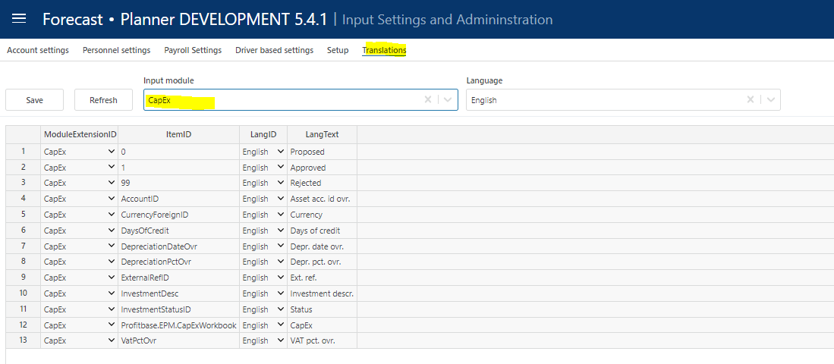

Select CapEx as the Input module and the language of choice.

Edit the Lang Text column of an item or add an item. The available ItemID are typically the various column ids such as InvestmentDesc, etc.

Settings

The investment settings are defined in the “Setup” page of the “CapEx” workbook. Select the “Settings” tab:

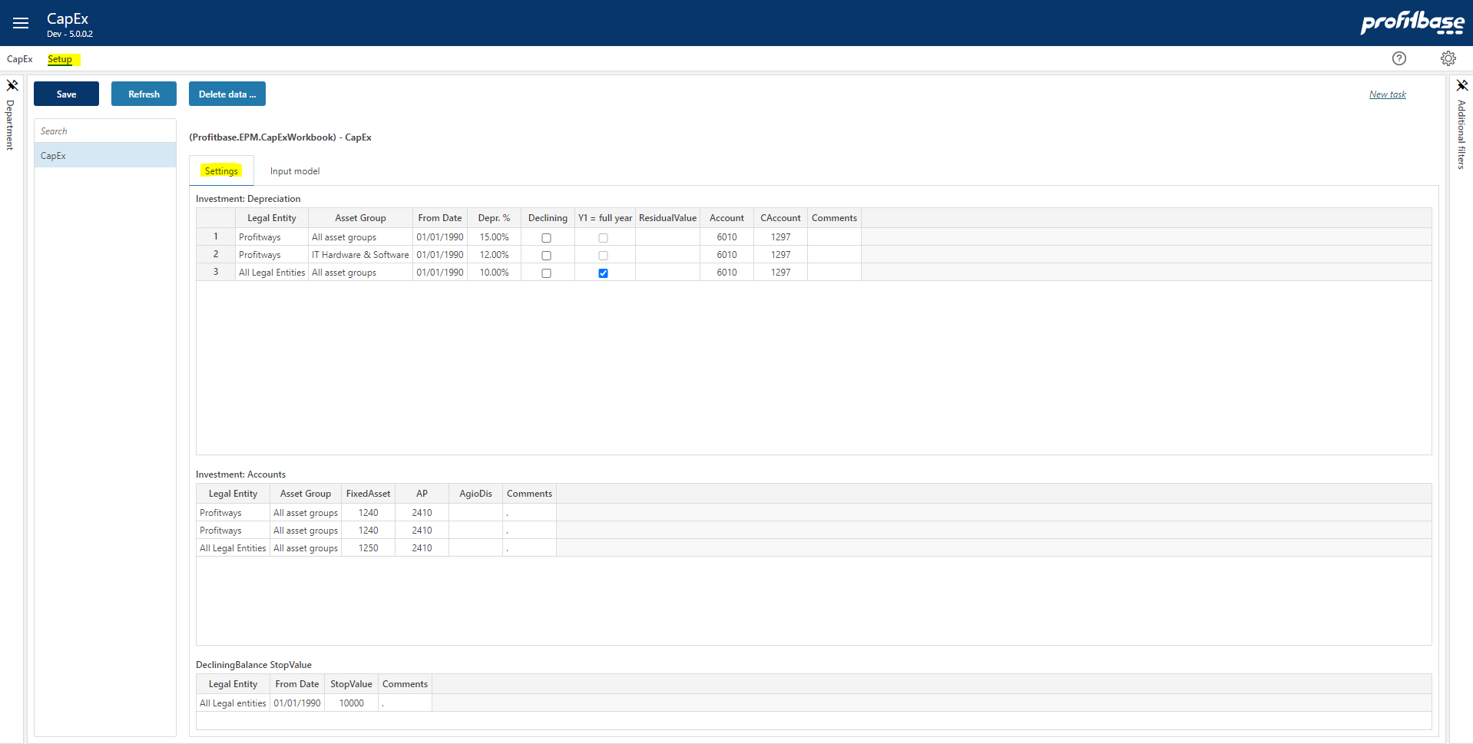

Investment Depreciation
This setting table defines the rules for looking up depreciation rates and associated deprecation accounts and depreciation counter accounts.
Column | Description
Legal entity | Mandatory. Ranked input. Legal entity for which the setting applies.
Asset group | Mandatory. Ranked input. Asset group for which the setting applies.
From date | Mandatory. Preset with default. Date from which the setting is valid. Any qualifying setting with an older From date will no longer take effect.
Depr % | Mandatory. Numeric. The depreciation rate.
Declining | Checked = Declining balance, unchecked = Straight line
Y1 = full year | Checked = full year of depreciation in Y1, unchecked = depreciation from start date
Residual value | Residual value (stops depreciation, leaves residual value)
Account | Mandatory. The account to which the calculated depreciation will tied.
CAccount | Mandatory. The counter account for calculated depreciation.
Comments | Optional comment.

Note that if the setting table is refined down to individual asset groups, the “AssetGroupID” dimension should be visible in the input sheet, refer to Dimension setup for details.

Investment Accounts
This setting table defines the asset account and accounts payable regime.

Column | Description
Legal entity | Mandatory. Ranked input. Legal entity for which the setting applies.
Asset group | Mandatory. Ranked input. Asset group for which the setting applies.
Fixed asset | Mandatory. The asset account that the investment will be tied to.
AP | Mandatory. The accounts payable account that the investment will be tied to.
AgioDis | Optional. The account that any agio / disagio will be tied to.
Comments | Optional comment

Note that if the setting table is refined down to individual asset groups, the “AssetGroupID” dimension should be visible in the input sheet, refer to Dimension setup for details.

Declining Balance StopValue
DecliningBalanceStopValue is setting the current lowest residual value of fixed assets, before the account balance is depreciated to zero in one go. I.e. The limit to stop calculating depreciation on an asset.

Column | Description
Legal entity | Mandatory. Ranked input. Legal entity for which the setting applies.
From date | Mandatory. Preset with default. Date from which the setting is valid. Any qualifying setting with an older From date will no longer take effect.
Stop value | Mandatory. Numeric. The actual stop value
Comments | Optional comment

